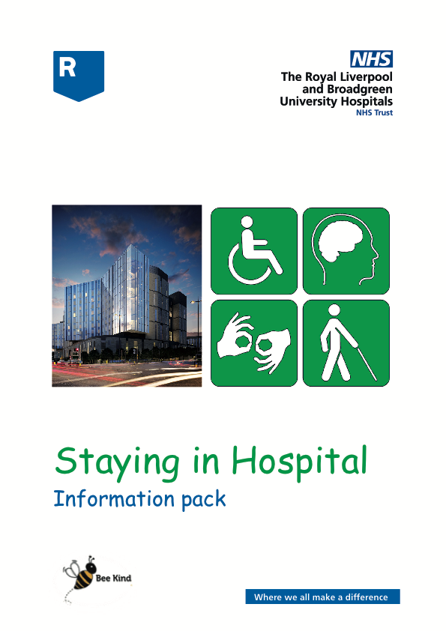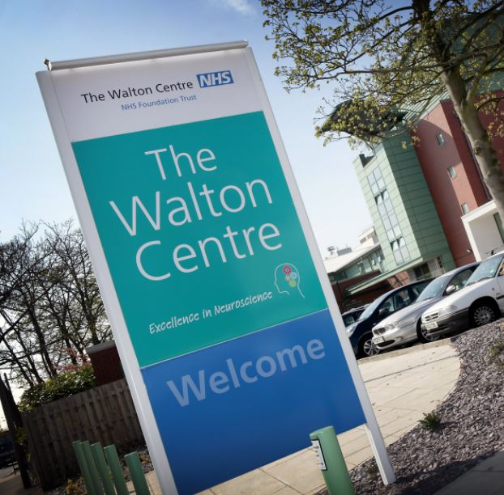



****

**Contents:**

|  |  |  |
| --- | --- | --- |
| https://cdn.shopify.com/s/files/1/0606/1553/products/Ultrasound_Gown_large.png?v=1417849596Image result for thumbs up photo | **Introduction** | **3** |
| https://cdn.shopify.com/s/files/1/0606/1553/products/Supporter_Car_compact.png?v=1417857129 | **About staying in hospital** | **4** |
|  | **Getting to hospital** | **6** |
| https://cdn.shopify.com/s/files/1/0606/1553/products/Consent-Form-Sally_compact.png?v=1417856324 | **What happens when you get to hospital** | **7** |
| https://cdn.shopify.com/s/files/1/0606/1553/products/Hospital_Bed_Alone_compact.png?v=1417849194 | **Consent** | **9** |
|  | **Staying in hospital** | **11** |
| https://cdn.shopify.com/s/files/1/0606/1553/products/Wash_Hands_compact.png?v=1417854817 | **Infections** | **13** |
| https://cdn.shopify.com/s/files/1/0606/1553/products/Acute-Liaison-Nurse_compact.png?v=1417848650https://cdn.shopify.com/s/files/1/0606/1553/products/Care-After-Hospital_compact.png?v=1426967386 | **Who are the Learning Disability Team** | **14** |
|  | **Leaving hospital** | **15** |
| https://cdn.shopify.com/s/files/1/0606/1553/products/Mother_daughter_compact.png?v=1417850045 | **Further Information** | **16** |
| https://cdn.shopify.com/s/files/1/0606/1553/products/Information_Sign_large.png?v=1417850564https://cdn.shopify.com/s/files/1/0606/1553/products/Information_Sign_large.png?v=1417850564 | **Other useful information** | **21** |
|  | **Support Organisations** | **22** |

**Introduction**

This booklet is for patients with a learning disability, your carers, friends and relatives.

It will help you to understand what it will be like when you stay in our hospital. We know coming into hospital may be a difficult time for you so we want to make sure we get it right.

Our priority is that people with learning disabilities receive the right support for their individual needs and are treated in a person centred way.

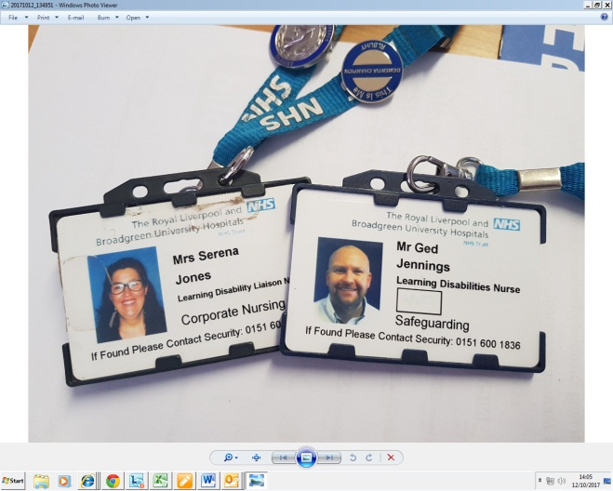

It is very important that you feel safe when you are in hospital. All staff will have a badge with their picture, name and job title.

If you your relatives or carers feel worried about anything, or you think you have been treated unfairly please speak to a member of staff.

**About staying in hospital (Inpatient)**

|  |  |
| --- | --- |
| https://cdn.shopify.com/s/files/1/0606/1553/products/Acute-Liaison-Nurse_compact.png?v=1417848650https://cdn.shopify.com/s/files/1/0606/1553/products/Hospital_Bed_Empty_compact.png?v=1417849198 | If you have to stay in hospital overnight you are called an **Inpatient** |
| https://cdn.shopify.com/s/files/1/0606/1553/products/Short_break4_compact.png?v=1417850108 | You will need to pack a bag |
| http://3.imimg.com/data3/JN/IQ/MY-239676/pyjamas-for-women-250x250.jpg  https://cdn.shopify.com/s/files/1/0606/1553/products/Slippers2_large.png?v=1417847747  https://cdn.shopify.com/s/files/1/0606/1553/products/Teeth_clean1_compact.png?v=1417850162 | Please pack:   * night dress or pyjamas * Dressing gown * Slippers * Toiletries * Soap & flannel, * Toothbrush & Toothpaste * shampoo & conditioner * razor * deodorant * hairbrush |
| https://cdn.shopify.com/s/files/1/0606/1553/products/Hearing_Aid_compact.png?v=1417847005  https://cdn.shopify.com/s/files/1/0606/1553/products/Teeth-Model_compact.png?v=1417849542 | If you need them, please also bring   * Glasses * False teeth (and the container) * Hearing aid |
| https://cdn.shopify.com/s/files/1/0606/1553/products/Medication_compact.png?v=1417849318 | Please bring your medicine or tablets. Bring the boxes for your tablets too. This helps the doctor to know what they are. |
| https://cdn.shopify.com/s/files/1/0606/1553/products/Reading-News-Guilty_compact.png?v=1417846842  https://cdn.shopify.com/s/files/1/0606/1553/products/Crisps_compact.png?v=1417848212 | If you want a newspaper or snacks, please bring a little bit of money. |
|  | If you have a health passport, please bring this with you too.  (see page 22 to explain what this is) |
| https://cdn.shopify.com/s/files/1/0606/1553/products/Letter_read2_compact.png?v=1417853139 | Please bring the letter from the Hospital |
|  | Please do not bring:   * Televisions or radios (we have these) * Alcohol * Anything valuable (like jewellery or lots of money) |

**Getting to the hospital**

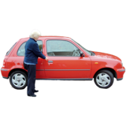

|  |  |
| --- | --- |
|  | If someone is driving you to hospital, please show them the instructions on page 17. |
| https://cdn.shopify.com/s/files/1/0606/1553/products/Taxi_compact.png?v=1417858512  https://cdn.shopify.com/s/files/1/0606/1553/products/Bus-2_compact.png?v=1421924045 | If you are getting a taxi, please ask the driver to take you to the main entrance . |
| https://cdn.shopify.com/s/files/1/0606/1553/products/Ambulance_compact.png?v=1417848658 | If you use public transport, please make sure you know the route well.  www.merseytravel.gov.uk will provide more information |
|  | A few people need an ambulance to bring them to hospital.  The hospital letter tells you how to book an ambulance. |
| C:\Users\jenkins-d\AppData\Local\Microsoft\Windows\INetCache\Content.Outlook\NX8P12M6\external 1 may 2013.JPG | The main entrance to the hospital looks like this. |

**What happens when you get to hospital?**

|  |  |
| --- | --- |
|  | Please go to the main reception desk.  Show them your hospital letter.  Someone will tell you how to get to the **ward**. |
| **C:\Users\jenkins-d\AppData\Local\Microsoft\Windows\INetCache\IE\353UUJIQ\Empty-hospital-ward-007[1].jpg** | A **ward** is the name for a room where you sleep when you are staying in hospital. |
|  | When you get to the ward a nurse will say hello and introduce themselves.  They will tell you what happens on the ward.  You can ask them questions about staying in hospital. |
|  | The nurse will ask you questions about you. You can bring your LD Health Passport with you to share with staff.  A member of staff will write down what you say. This helps everyone know what you like and how to look after you. |
| https://cdn.shopify.com/s/files/1/0606/1553/products/Checklist_Good-2_large.png?v=1417850461https://cdn.shopify.com/s/files/1/0606/1553/products/Checklist_Bad-2_compact.png?v=1417847359 | You are allowed to see what we write down about you.  You can tell us if you do not want us to share this information. |
| Image result for colouring in books | If you would like some extra company we have volunteers who can come and chat with you or find activities for you to do together. |

**Consent**

|  |  |
| --- | --- |
| https://cdn.shopify.com/s/files/1/0606/1553/products/Consent-Form-Sally_compact.png?v=1417856324 | We will ask you to say if it is okay to treat you. This is called **Consent.** |
| https://cdn.shopify.com/s/files/1/0606/1553/products/Consent-Form-Yes_compact.png?v=1417856326 | To give consent, you might have to sign a form or we will help you to record this. |
| https://cdn.shopify.com/s/files/1/0606/1553/products/Question_compact.png?v=1417847444 | Please ask any questions you have about the treatment. |
| https://cdn.shopify.com/s/files/1/0606/1553/products/Anaesthetist_compact.png?v=1417848663 | If you don’t understand what the doctor is saying, please ask them to explain it in a way that you can understand. |
|  | The Senior Nurses can also support you to understand about your treatment. |
| https://cdn.shopify.com/s/files/1/0606/1553/products/Consent-Form-No_compact.png?v=1417856320 | You can change your mind even after you have signed the form.  This is called **withdrawing consent**. |
| https://cdn.shopify.com/s/files/1/0606/1553/products/Mother_daughter_compact.png?v=1417850045 | If you find it difficult to decide what to do, you can get support from your family, carers or advocate. |
| https://cdn.shopify.com/s/files/1/0606/1553/products/Clinical-Hold-2_large.png?v=1452802624 | A **best interest decision** takes place with those people who know you well and the people who know about your treatment.  This only happens when you are not able to decide for yourself. |
| https://cdn.shopify.com/s/files/1/0606/1553/products/Anaesthetist_compact.png?v=1417848663 | A **best interest decision** is made by your lead health professional. |

**Staying in hospital**

|  |  |  |
| --- | --- | --- |
| https://cdn.shopify.com/s/files/1/0606/1553/products/Choose_Food_compact.png?v=1417849767  https://cdn.shopify.com/s/files/1/0606/1553/products/Omelette_Salad_compact.png?v=1417848405https://cdn.shopify.com/s/files/1/0606/1553/products/Time-5-00_compact.png?v=1494015275https://cdn.shopify.com/s/files/1/0606/1553/products/Time-6-00_compact.png?v=1494015811https://cdn.shopify.com/s/files/1/0606/1553/products/Time-12-00_compact.png?v=1494062376https://cdn.shopify.com/s/files/1/0606/1553/products/Time-1-00_compact.png?v=1494010662https://cdn.shopify.com/s/files/1/0606/1553/products/Time-8-00_compact.png?v=1494060363https://cdn.shopify.com/s/files/1/0606/1553/products/Time-8-30_compact.png?v=1494060151 | **Meals**  There is a menu for you to choose what you want to eat. Somebody will ask you what you would like to eat.  If eating some foods will make you sick, please tell us. We can ask the kitchen to make something else.  Meal times are:  Breakfast 8am-8.30am  Lunch 12-1pm  Dinner 5pm-6pm  If you are about to have an operation, you won’t have anything to eat or drink until afterwards. |  |
| **C:\Users\jenkins-d\AppData\Local\Microsoft\Windows\INetCache\IE\O5J8SHRI\vending_machine[1].jpg**Image result for drinks snacks | There is a cafe in the hospital where you can buy drinks and food. There are also vending machines to buy snacks.  In **The Walton Centre Main building** these are by the main reception desk. |  |
| https://cdn.shopify.com/s/files/1/0606/1553/products/Wardrobe_compact.png?v=1417850185 | You will have a small cupboard by your bed to put your belongings into.  Please remember not to bring anything valuable to hospital. |  |

|  |  |
| --- | --- |
| https://cdn.shopify.com/s/files/1/0606/1553/products/Visiting-Hours_98bf4217-1452-424d-8a38-d3cc22cbf285_large.png?v=1494175527 | Your friends and family are allowed to come and visit you in the afternoon and evening.  If you need extra support, a family member or carer is allowed to stay longer.  We can offer **flexible visiting hours**. |
| https://cdn.shopify.com/s/files/1/0606/1553/products/Night_compact.png?v=1417858322  https://cdn.shopify.com/s/files/1/0606/1553/products/Sleep-2_large.png?v=1417850139 | At night time most of the lights are turned off so that you can sleep. |
| https://cdn.shopify.com/s/files/1/0606/1553/products/Place_No_Smoking_compact.png?v=1417855780  https://cdn.shopify.com/s/files/1/0606/1553/products/Lager_compact.png?v=1417848336 | Alcohol and smoking are not allowed in the hospital.  We can support you with ways to stop smoking if you would like to. |

**Infections**

|  |  |
| --- | --- |
| https://cdn.shopify.com/s/files/1/0606/1553/products/Hospital_Hand_Rub_compact.png?v=1417849232 | **Infection** means there is something in your body that should not be there.  Infections can make you very sick so it is important to stop them. |
| https://cdn.shopify.com/s/files/1/0606/1553/products/Wash_Hands_compact.png?v=1417854817  https://cdn.shopify.com/s/files/1/0606/1553/products/Blow-Nose-Tissue_compact.png?v=1417848701 | You can help stop infections:   1. **Wash your hands** and use the hand gel.   Do this when you go into the ward before you eat and when you go to the toilet.   1. Ask the doctors, nurses and your visitors to wash their hands too. 2. If your friends or family are unwell they should not visit you until they have been well for 2 days. |
| https://cdn.shopify.com/s/files/1/0606/1553/products/Clinical-Hold-8_compact.png?v=1452801941 | If you have had an operation, it is very important you **do not touch your wound** or allow any of your visitors to touch it. |

**The Walton Centre NHS Foundation Trust’s Learning Disability Link Nurse**

**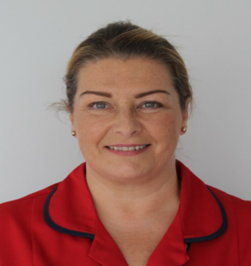**

**Debbie Lee –**

**Matron for Safeguarding**

Her phone number is: **0151 556 3307**

Our email address is: [safeguarding@thewaltoncentre.nhs.uk](mailto:safeguarding@thewaltoncentre.nhs.uk)

Our Safeguarding team telephone number is: 07929 763709

**Leaving hospital**

|  |  |
| --- | --- |
| https://cdn.shopify.com/s/files/1/0606/1553/products/Care-After-Hospital_compact.png?v=1426967386  https://cdn.shopify.com/s/files/1/0606/1553/products/Care-Coordinator_compact.png?v=1491048124 | Leaving hospital is called **discharge**. |
|  | You might need some extra support.  A member of our hospital staff will talk to you and your family/carer about this. |
| https://cdn.shopify.com/s/files/1/0606/1553/products/Nurse_Bandage_compact.png?v=1417849395 | The Multidisciplinary Team can support with your discharge if you want our help.  The Hospital will make sure you have the right medicine to go home with. |
| https://cdn.shopify.com/s/files/1/0606/1553/products/Information_Sign_large.png?v=1417850564 | On page 21 there is a list of support organisations that can support you when you leave hospital. |

**Further Information**

This part of the booklet is providing more detailed information about our hospital. The Easy Read section is at the beginning.

We appreciate a person with learning disabilities may face one or more of the following challenges;

* Comprehension – understanding what is said or meant.
* Expression – making themselves understood and expressing their needs.
* Attention deficit – concentration may be limited.
* Perception – events, language and the world we live in may differ from others.
* Short term memory – may be limited.
* Long term memory – there may have been a negative experience of coming to hospital in the past.
* Coping with change – is often a challenge.
* Eating problems – some people may have difficulty eating and swallowing foods.

Our staff are here to support people with a Learning Disability who have complex needs and their relatives and carers.

**The Walton Centre Parking:**

Pay and display car parking is located in front of The Walton Centre main building and the Sid Watkins Building.

There is also a multi-story car park with a link bridge to The Walton Centre main building.

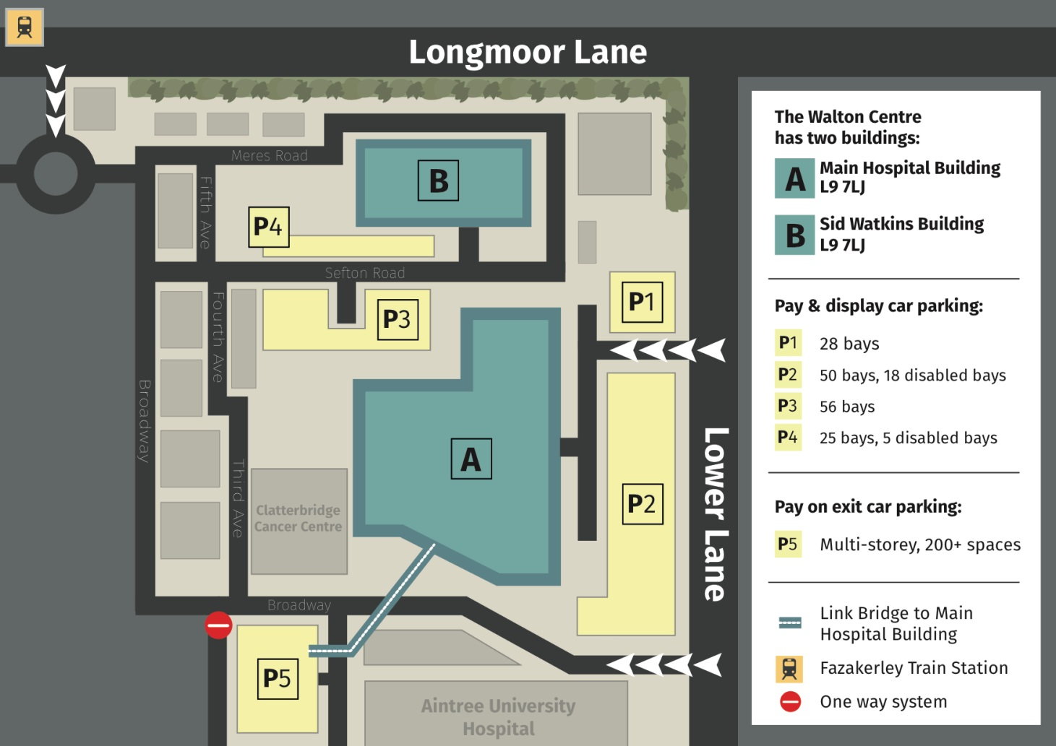

**Consent**

People with a learning disability, aged 18 and over, have same legal rights and freedoms as anyone else. To have capacity to consent to healthcare decisions, a person must demonstrate they can:

* understand the relevant information;
* retain it long enough to balance out the risks and benefits, and;
* Communicate their choice (using verbal or non-verbal methods).

To support a patient’s right to consent the hospital will always try to explain the treatment. This will be done in a way that is easy for the patient to understand. Involving family/carers (i.e. asking their opinion), this does not indicate that the individual lacks capacity. It is common for any patient to speak to their family before deciding on treatment.

If a patient does lack capacity to make a decision about treatment, the ward will hold a ‘best interest’ meeting. We involve the patient and their family/carer in order to understand the patient’s wishes, so that we can make a **best interest decision.**

**Reasonable Adjustments**

Health and care services are legally required to make ‘reasonable adjustments’ for people with learning disabilities under the Equality Act (2010), ensuring equal and fair treatment.

Some examples of reasonable adjustments in a hospital setting include:

* Providing easy-read information to people with learning disabilities
* Giving longer appointment times with doctors and nurses
* Flexible Visiting Hours for parents/carers.
* Appropriate/ Convenient times for meetings, procedures and investigations.

Health professionals should listen to the family/carers of people with learning disabilities.

**Health Passport**

Family/carers usually know most about the patient and the support they need. The family/carers can also be involved in providing information for any reasonable adjustments that may be needed.

Information about reasonable adjustments that a patient may find helpful can be written in their health passport.

If the person you care for does not have a health passport already, or it needs updating, there is a blank passport provided with this information pack. Please remember to prompt the person you care for to bring their hospital passport with them to hospital.

The health passport is a really useful booklet to help hospital staff understand a patient’s needs. The health passport gives us information about the whole person, not just information about their medical conditions. It can include lists of their likes and dislikes, including their favourite food and drink and personal interests.

**Accessible Information**

The Multidisciplinary team can help to explain medical conditions and their treatments by using pictures and photographs. The Multidisciplinary team has many documents available in Easy Read to help patients understand and make informed choices about their care.

**Bedside support**

We know that being in hospital is something that many people find distressing. Being in an unfamiliar surrounding can make people feel anxious and we know this may cause patients to appear agitated or distant. The hospital has various ways of reducing anxiety so please speak to a member of staff so that they can understand the best ways to support the patient.

The hospital has a dedicated Volunteer Support Team who work with patients with learning disabilities to help provide ward based activities and support.

**Flexible visiting**

If you are visiting a patient who has a learning disability, we allow visiting outside of the standard set hours for the ward. This means that you can for example, arrange to visit during meal times if this might help the patient to feel comfortable when eating. Please speak to the ward manager to arrange visits outside the set times.

**Other useful information**

|  |  |
| --- | --- |
| https://cdn.shopify.com/s/files/1/0606/1553/products/Information_Sign_large.png?v=1417850564 | This section contains information to help you stay healthy |
| Home | **Easyhealth** is a website with lots of information about health.  The information is easy to read and there are videos too. |
|  | There are over 500 leaflets on Easyhealth, made by many different organisations.  You can print off nearly all the leaflets straight away. |
| https://cdn.shopify.com/s/files/1/0606/1553/products/Point-Blank-Paper-Woman-1_compact.png?v=1417850671  https://cdn.shopify.com/s/files/1/0606/1553/products/Years-2018_compact.png?v=1487798283 | The learning disability register is a list of people with a learning disability who access their GP. Ask your doctor to add your name to the **learning disability register** if you are not already on it**.**  An Annual Health Check is done by your GP once a year. You can get an Annual Health Check if you are age 14 or older. It can help you stay healthy. You do not need to be ill to have an annual health check. |

**Support Organisations**

|  |  |
| --- | --- |
| This section has information about different organisations who give advice and support to both people who have a learning disability and their family or carer. | |
|  | **Mencap Liverpool**  [www.mencapliverpool.org.uk](http://www.mencapliverpool.org.uk)  0151 707 8582 |
| Wirral Mencap | **Wirral Mencap**  [info@mencapwirral.org.uk](mailto:info@mencapwirral.org.uk)  <http://mencapwirral.org.uk/>  0151 666 1829 |
| Image result for people first merseyside | **People First Merseyside**  <https://www.peoplefirstmerseyside.co.uk/>  Liverpool: 0151 707 6751  Sefton: 0151 329 2137 |
| KDC | **Knowsley Disability Concern**  <http://www.kdc.org.uk/>  0151 480 4090 |
| Image result for options for supported living | **Options**  http://www.optionsforsupportedliving.org/  0151 236 0855 |
| Image result for pss | **PSS- Person shaped support**  http://www.psspeople.com/  **0151 702 5555** |
| Image result for mersey care ld | **Mersey Care NHS Trust**  Learning Disabilities Service  0151 737 4800  Sefton Community Learning Disability Team  01704 383030/383114 |
| Image result for united response | **United Response**  <https://www.unitedresponse.org.uk/>  0208 246 5200 |
| Image result for mencap logo | **National Mencap**  [www.mencap.org.uk](http://www.mencap.org.uk)  0808 808 1111 |
| Image result for bild logo | **British Institute of Learning Disabilities - BILD**  [www.bild.org.uk](http://www.bild.org.uk)  0121 415 6960 |
| Image result for foundation for people with learning disabilities logo | **Foundation for People with Learning Disabilities**  www.learningdisabilities.org.uk  020 7803 1100 |

**Acknowledgements:**

This information pack was designed by the Cheshire and Merseyside Learning Disability Network Group and reviewed by members of Mencap Liverpool.

